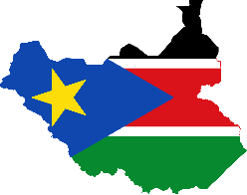
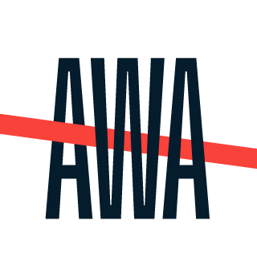
South Sudan Watch Update
4 – 10 May 2018

Ruling party meets for unification meeting
The ruling party in South Sudan, the SPLM held a meeting on Thursday 3 May in a bid for reunification. The meeting was held in South Sudan capital Juba under the supervision of the Ugandan president Yoweri Museveni and the Egyptian Foreign Minister Sameh Shoukry. The meeting is another attempt by the ruling party to unify with its other factions that include the SPLM-IO and the former detainees. During the meeting the Uganda president told the attendees not to resort to violence because there is no need for enmity amongst the factions. President Museveni said "Force is like surgery. It should be the last resort to removing a tumour. If you use the knife to cut anyhow, you cease to be a surgeon, you become a butcher.”
Fighting breaks out again
The armed opposition group SPLA-IO reported an attack on their outposts by government backed forces on over the weekend. The spokesperson of the rebel group Brig. Gen. William Gatjiath said that they wee attacked by government troops in the outposts in Pinythor, Turul, and Nguankei on Saturday morning at about 5 am but they were able to fight back and repulse the troops. The rebels then mounted an offensive into Pagak town where they killed at least 54 government troops and took over a huge part of Pagak town. Brig. Gen. Gatjiath said that they now have control over about 95% of Pagak town after they attack the mounted on the government troops.
In a separate statement the government troops accused the rebels of attacking their bases in Pagak and violating the cessation of hostilities agreement. Col. Dickson Gatluak of the SPLM said, “Our forces had to strike back heavily in order to end the assaults and repulsed them [rebels] back to where they came from and we rejuvenated back to our barracks at 6:00AM this morning.”

Salva Kiir allows Riek Macher to return to South Sudan
The president of Salva Kiir requested the former vice president Riek Macher to return home to South Sudan. During a meeting with the National Leadership Council, the president asked the IGAD ministers of foreign affairs to allow Dr. Riek Machar to return home to Juba. He added that he would be protected by the Regional Protection force should he choose to return. Salva Kiir added that the return of Macher would expedite the peace process and the reunification of the ruling party.
The members of the SPLA-IO which Dr. Machar heads say that they will not allow their leader to return to South Sudan without armed forces. Manawa Peter Gatkuoth, deputy head of the SPLM’s committee for information said that they cannot allow their chairman to return without armed forces equal to those of the government in Juba.
UN warns South Sudan against elections
The United Nations Assistant Secretary General for peace operations Bintulu Keita released a statement in which she called the South Sudan government’s plan to hold elections should the revitalization process fail as unreasonable. She added that the situation in South Sudan does not allow for free and fair elections and she asked the government to stay away from the idea of elections.
UN votes to renew sanctions on South Sudan
The Security council unanimously adopted a resolution for the renewal of sanctions on South Sudan for another year. The sanctions imposed include asset freeze and travel bans for all those people and entities that threaten the peace of South Sudan.

“Museveni urges rival S. Sudan ruling party factions to unite,” 4 May 2018, Sudan Tribune, available at http://www.sudantribune.com/spip.php?article65326
“Heavy fighting erupts in Pagak as rebels seize the main bridge” 5 May 2018, South Sudan News Agency, available at http://southsudannewsagency.org/index.php/2018/05/05/heavy-fighting-erupts-in-pagak-as-rebels-seize-the-main-bridge/
“S. Sudan government accuses rebels of attacking Pagak,” 5 May 2018, Sudan Tribune, http://www.sudantribune.com/spip.php?article65334
“PRESIDENT KIIR WANTS HIS ARCH RIVAL MACHAR RETURNS TO JUBA TO BE PROTECTED BY THE RPF,” 4 May 2018, Nyamilepedia, available at http://nyamile.com/2018/05/04/breaking-president-kiir-wants-his-arch-rival-machar-returns-to-juba-to-be-protected-by-the-rpf/
“Machar will not return without forces' say rebels,” 9 May 2018, Radio Tamazuj, available at https://radiotamazuj.org/en/news/article/machar-will-not-return-without-forces-say-rebels
“UN warns South Sudan against holding elections,” 7 May 2018, South Sudan News Agency, available at http://southsudannewsagency.org/index.php/2018/05/07/un-warns-south-sudan-against-holding-elections/
“UN Security Council renews sanctions on war-torn S. Sudan,” 9 May 2018, Sudan Tribune, available at http://www.sudantribune.com/spip.php?article65367

