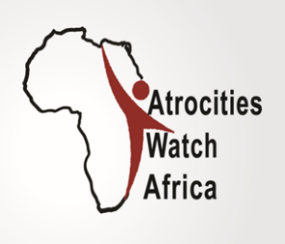

Burundi Watch Update
11-17 September 2017

Summary

While Burundi authorities are extremely busy denying crimes against humanity, several dead bodies are being found in several locations of the country; and arbitrary arrests and abductions continue. In the same vein Burundians were utterly shocked as they learnt of the killing of dozens of asylum seekers in Kamanyola in the neigbouring DRC.

Dozens of Burundi asylum seekers killed in Kamanyola in the DRC
Burundians were utterly shocked as they learnt on Friday the 15th September 2017, the bloodshed of 36 Burundians shot dead by Congolese security forces whereas an estimated number of 150 individuals were wounded. Several sources suggest that the victims were members of the sect of Euzébie, led by a lady who preached for many years in the North of Burundi and who reportedly retired in the DRC. Before the butchery, Kirundiphone people reportedly inspected the area, threatening the asylum seekers. This leads some to strongly believe the involvement of Burundi secret agents in the assassination of the Burundian asylum seekers.

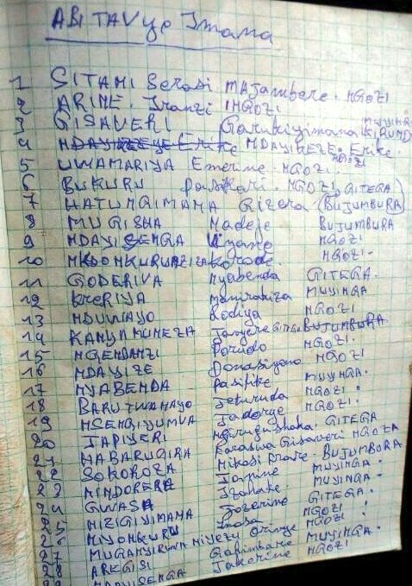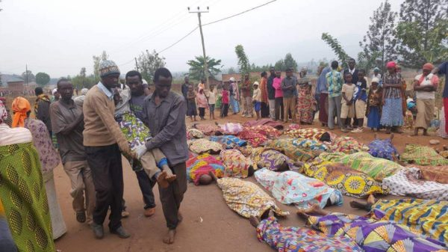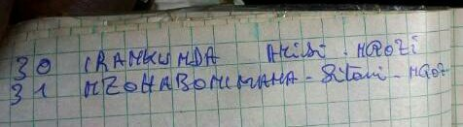
The list of 31 victims shot dead on 15 September 2017

Burundi authorities deny crimes against humanity
Since the release of the final report of the commission of inquiry(COI) on Burundi on 4 September 2017 which concluded that crimes against humanity were committed in the country, several institutions rose to actively protest against the report. On 12 September 2017, the Spokesperson of the Government, Philippe Nzobonaribasuggested that the COI was created by force and to speed up the way towards the ICC. According to the spokesperson, this justifies the reason why the government refused to grant the human rights council’s commission access to the national territory. He argued that the commission shows compassion to the victims instead of identifying the authors of several crimes. He also argued that the commission was created to support the ICC with the purpose of destabilizing the country. On 8 September 2017, the Parliament echoed the government as it submitted a letter to the Secretary General of the UN informing the creation of the special commission in charge of verification of the report of the human rights council appointed commission. The National Assembly argued that it is against any action likely to influence and manipulate the ICC to open an inquiry as a means of pressure and an attack to the sovereignty of Burundi.
Surprisingly, on 11 September 2017, while many expected the National Institution of Human rights to support efforts of the fight against impunity, the President of the CNIDH, Jean Baptiste Baribonekeza released a statement supporting the government and the parliament, rejecting the report and arguing that the commission only listened to a part of the victims, mainly refugees and that the commission reported on unchecked facts as it never came to Burundi. It is worth recalling that Burundi authorities refused to grant the human rights council appointed commission access to the national territory from the time of its creation.
New families of the victims approach the ICC
In a statement released on 13 September 2017, the Coalition of Lawyers of the Victims of the crimes of international Law (CAVIB) submitted 53 new communications to the Prosecutor of the ICC. The statement stressed that the files provide evidences on the occurrence of grave crimes falling under the jurisdiction of the ICC. CAVIB called upon the Prosecutor of the ICC to urgently open an investigation in the situation of Burundi. The CAVIB supports the commission of inquiry on Burundi and demands its mandate be extended for more time to allow further investigations. In the same vein, on 18 and 19 September 2017, the coalition of lawyers of the civil parties made 107 mandates and a list of 594 complaints, all FNL members.
Hate speech

As dozens of CNDD-FDD militants gathered on Satureday 16 September 2017 to protest against the final report of the commission of inquiry on Burundi, the Secretary General, General Evarsite Ndayishimiye made a vibrant speech under the rhythm of “Caratuvunye” ( we were exhausted as we fought for the country) and “ntakugugumwa”( never fear!). General Ndayishimiye explained that the CNDD-FDD originates from death and is the one who resurrected Burundians who were living in slavery. He stated that the United Nations were fooled to send Belgium to kill Burundians, divide them, rob them, and tie them as the UN watched. General Ndayishimiye stressed that some Burundians including catholic church leaders who claimed injustice and exclusion in the past are the ones supporting the enemy as if the latter have changed.

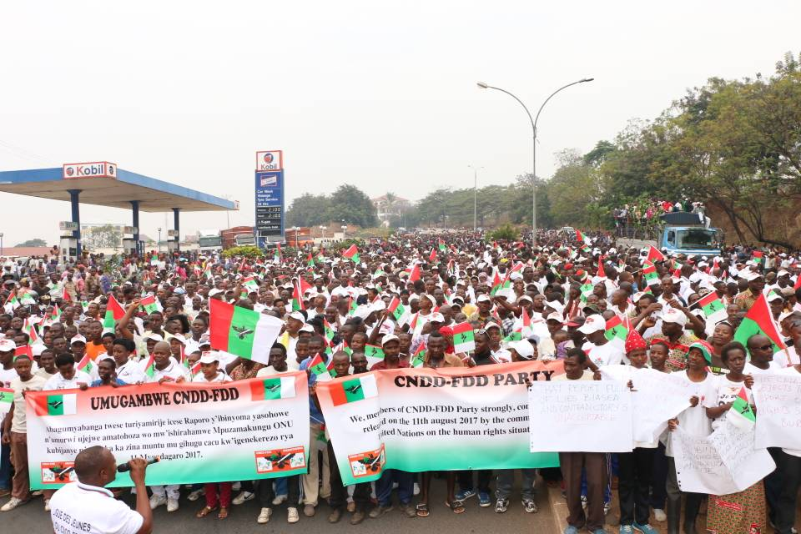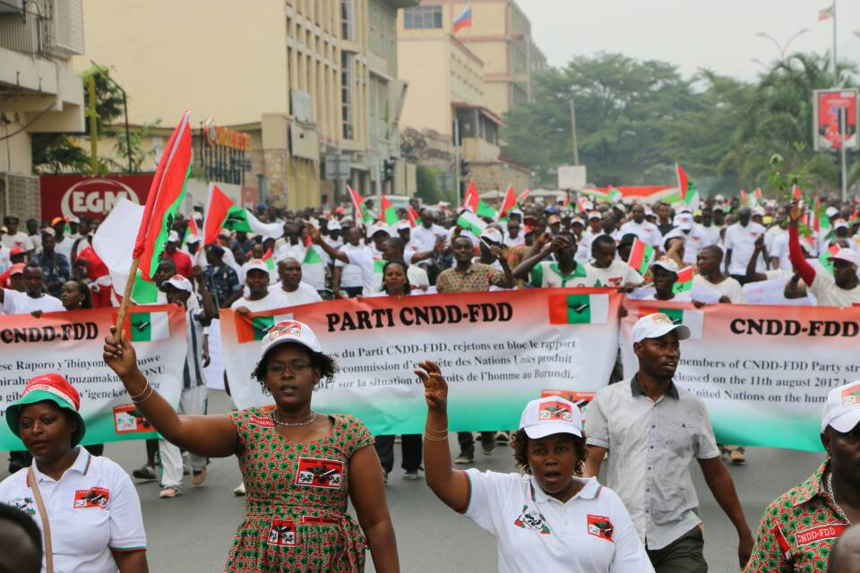
CNDD-FDD militants protesting against the report of the commission of inquiry on 16 September 2017 in Bujumbura.Credit: Ikiriho on twitter

Killings, grenade attacks and gunshots
Some of the reported cases of killings and grenade attacks include:

- On 10 September 2017, the dead body of Daniel GAHUNGU was recovered in Bihanga in the District of Gitega
- On 11 September 2017, a dead body of a man known as Movit was recovered in Kamesa in the District of Musaga. His hands and legs were tied and the front showed several wounds
- On 11 September 2017, Four (4) persons were killed whereas 2 were wounded by unknown gunmen in Rubirizi in the District of Mutimbuzi at the edge of Gikoma river
- On 12 September 2017, intensive gunshots were reported at the office of the high commissioner for human rights located at Street Mugamba in Rohero in the City of Bujumbura. Whereas the police denied the knowledge of the attack, the Prosecutor stated that unidentified gunmen got into in the office with fake keys.
- On 13 September 2017, a dead body was buried in Kiyabu in the District of Butaganzwa
- On 14 September 2017, the dead body of Deo Wisezerano was recovered in Songa in the District of Gitega.
- On 14 September 2017, the dead body of Suavis Ntahonicaye was recovered in her house situated at Rutegama hill in the District of Gitega

Arbitrary arrests and abductions

Some of the arrests and abductions that were reported during the period report:

- On 9 September 2017, Appolinaire Ntikazohera, Antoinette and Dominique were arrested and tortured by Imbonerakure militiamen led by the chief of Zone Butezi Chief Zone in the District of Butezi
- On 11 September 2017, active military working with Muyinga Camp, Gérard Ntaconayigize was arrested in Bujumbura and taken to unknown destination
- On 12 September 2017, A member of UPD opposition party Léopold Habarugira was abducted from Mutanga Nord by the NIS and taken to unknown destination
- On 13 September 2017, Evariste Ndayishimiye was arrested and tortured by Imbonerakure militiamen at Kagazi Hill in the District of Rugombo

Atrocities Watch Africa

Atrocities Watch Africa (AWA) is a non-partisan, civil society organization and institution that intends to provide continental leadership in matters pertaining to the prevention of mass atrocities within Africa and beyond, through multi-pronged approaches that infuse ownership, legitimacy, and sustainable interface. AWA’s strategic and approaches are grounded in the realization that atrocities can be prevented through various interventions, including, but not limited to, early warning mechanisms, diplomatic efforts, use of social media and new technologies, litigation, and advocacy campaigns.

info@atrocitieswatch.org
www.atrocitieswatch.org
www.facebook.com/atrocitieswatch
www.twitter.com/atrocitiesw

See http://www.burundi.gov.bi/spip.php?article2775
See http://www.assemblee.bi/Resolution-portant-creation-d-une
Se http://cnidh.bi/sites/default/files/D%C3%A9claration%20du%2011%20septembre%202017.PDF
See http://avocatsdesvictimes.org/wp-content/uploads/2016/05/Communiqu%C3%A9-de-presse-du-CAVIB-qui-sanctionne-lenvoie-de-53-nouveaux-dossiers-%C3%A0-la-Cour-P%C3%A9nale-Internationale..pdf

